EWM AG to sponsor DVS Jugend Schweißt (Young Welder of the Year) competition
Putting our all into supporting young talent

EWM will once again sponsor the Jugend Schweißt competition held by the DVS (Deutscher Verband für Schweißen und verwandte Verfahren e. V., German Association for Welding and Related Processes). Every two years, young welders get together to test their various welding skills under competitive conditions. The competitions are held at regional, state and national level. As sponsor, EWM sends a positive signal in terms of the supporting of young talent and establishes ties with young people in the industry. The goal: to further boost the appeal of welding as a profession in an age when skilled workers are in short supply.

EWM has been sponsoring the DVS Jugend Schweißt competition for more than ten years now. The association sets the stage for young people aged between 16 and 23 to compare their expertise and practical welding skills with their peers in a competition format. Participants are tested in the disciplines of gas welding, arc manual welding, gas shielded arc welding of metal and Tungsten inert gas welding. It’s a unique experience where everyone with the required level of skill receives a welder’s certificate. The best young welders also have the chance to showcase their skills on the world stage at the European welding competition WELDCUP or China’s Arc Cup.

“Supporting young talent as much as possible”
EWM sponsors Jugend Schweißt with various prizes. Up for grabs are the Pico 160 MMA inverter welding machine, the fully automatic Powershield 2.5 welding helmet and multiple pairs of welder's gloves for MIG/MAG and TIG welding. Everyone who takes part in the competition, which EWM is sponsoring with a prize package, will also receive a digital welding dictionary, ensuring the young talent is ideally equipped for the big wide world of welding. “Even our industry is not immune to the current shortage of skilled workers. This makes it especially important to support and nurture young talent as much as possible,” says Susanne Szczesny-Oßing, Chair of the Supervisory Board of EWM AG and also President of the DVS since the beginning of the year.

EWM is focussed on young talent
Supporting young talent is something EWM holds dear, and not just in terms of its sponsorship of Jugend Schweißt. Within the company, there are almost 30 employees being trained in various areas. A new training workshop, including a learning area and workspaces for the trainees, is set to feature in the new production and logistics hall currently under construction at EWM’s headquarters in Mündersbach. On top of that, the company maintains partnerships with schools and collaborates with various universities and colleges in Germany and worldwide. Vocational colleges and universities are provided with free practical and theory-based training and workshops as well as welding machines and accessories. In addition, EWM works together with universities on research and development projects. The company also honours budding young scientists with the EWM Award every two years. The award comes with prize money of €30,000 and is considered the ultimate accolade in joining technology worldwide.

Date: 12 June 2019
Scope: 3,307 characters including spaces
Figures: 2

Fig. 1:
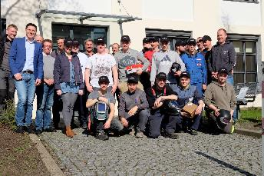
Participants of the regional competition in Dresden. Source: EWM

Fig. 2:
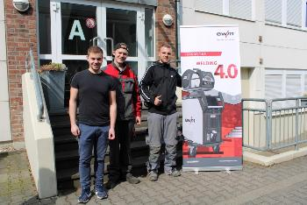
The winning team of the Niederrhein regional competition. Source: Kreiha Info

About EWM:
EWM AG is Germany’s largest and one of the most important worldwide manufacturers of arc welding technology. The family-run company from Mündersbach has been living its motto, “WE ARE WELDING”, with a great deal of passion for over 60 years, providing forward-looking and sustainable complete solutions for both industrial clients and craft businesses.
EWM develops high-end welding technology. The company, based in Germany’s Westerwald region, offers complete systems that cover everything from high-quality welding machines (and all associated components) to welding torches, welding consumables and accessories for manual and automated applications.
Users praise the products’ ease of operation and excellent results. Companies value the solid consultancy, service and enormous savings that come with EWM systems. The welding processes, some of which are patented, reduce the consumption of materials, energy and time during operation and produce up to 75 per cent fewer welding fume emissions.
The innovative welding technology manufacturer currently employs around 800 employees at 14 German and 7 international locations, with just under 400 based at its original headquarters in Mündersbach.

EWM AG company contact
Maja Wagener
Dr.-Günter-Henle-Str. 8
56271 Mündersbach, Germany
Telephone: +49 2680 181-434
Email: maja.wagener@ewm-group.com
Internet: www.ewm-group.com

Press contact
Jan Leins
additiv pr GmbH & Co. KG
Public relations for logistics, steel, industrial goods and IT
Herzog-Adolf-Straße 3
56410 Montabaur, Germany
Telephone: +49 2602 950 99-16
Email: jl@additiv-pr.de
Internet: www.additiv-pr.de

